- Area of polygons
1. The figure below is a squre based pyramid ABCD with AB = BC = 6cm and height VO = 10cm.
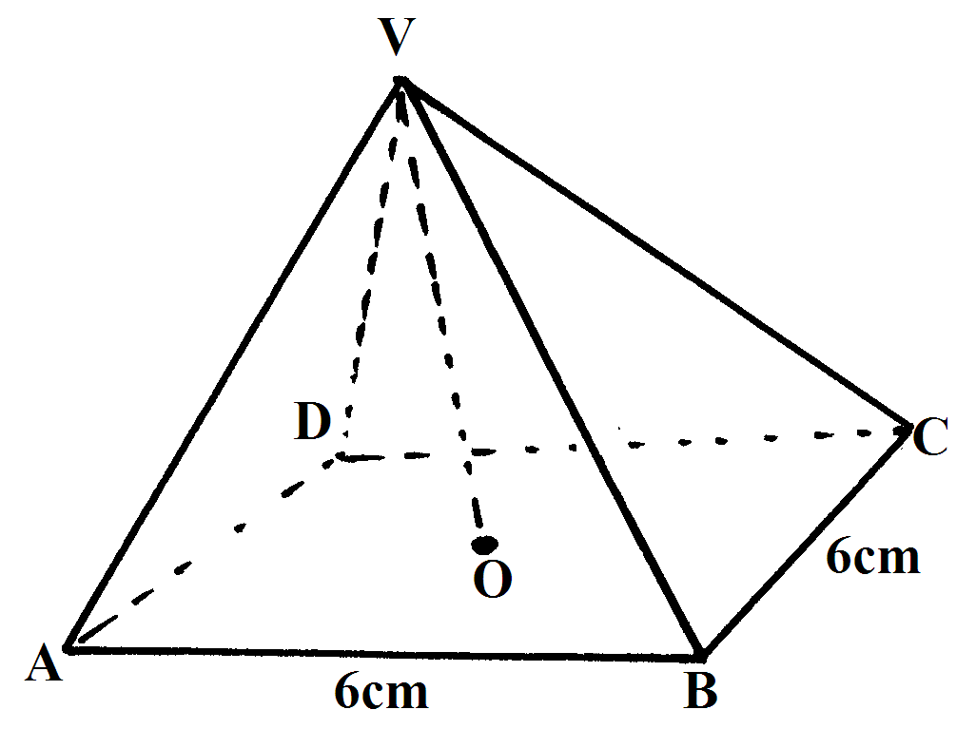

(a) State the projection of VA on the base ABCD. (1mk)
(b) Find the length VA. (3mks)
(c) Calculate angle between VA and plane ABCD. (2mks)
(d) Find angle between VCD and ABCD. (2mks)
(e) Calculate the volume of the solid (2mks)
2. The diagram below, not drawn to scale, is a regular pentagon circumscribed in a circle of radius 10 cm at centre O
10 cm
O

Find
(a) The side of the pentagon (2 mks)
(b) The area of the shaded region (3 mks)
3. PQRS is a trapezium in which PQ is parallel to SR, PQ = 6cm, SR = 12cm, 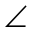PSR = 40⁰ and PS = 10cm. Calculate the area of the trapezium. (4mks)
40⁰
P
S
R
Q
>
>

4. A regular octagon has an area of 101.8 cm². calculate the length of one side of the octagon (4marks)
5. Find the area of a regular polygon of length 10 cm and side n, given that the sum of interior
angles of n : n –1 is in the ratio 4 : 3.

6. Calculate the area of the quadrilateral ABCD shown:-

14cm
6cm
12cm
18cm
C
B
A
D

